**Week 03-01:**

**Name: Snehan.s**

**Roll no: 241801272**

1. Write a program to read two integer values and print true if both the numbers end with the same digit, otherwise print false. Example: If 698 and 768 are given, program should print true as they both end with 8.

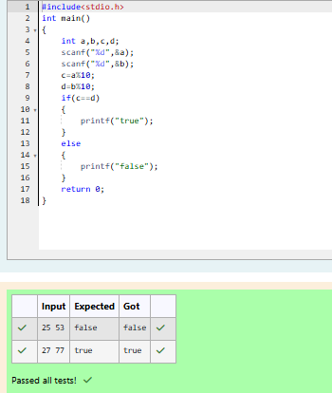

1. In this challenge, we're getting started with conditional statements. Task Given an integer, n, perform the following conditional actions: • If n is odd, print Weird • If n is even and in the inclusive range of 2 to 5, print Not Weird • If n is even and in the inclusive range of 6 to 20, print Weird • If n is even and greater than 20, print Not Weird Complete the stub code provided in your editor to print whether or not n is weird

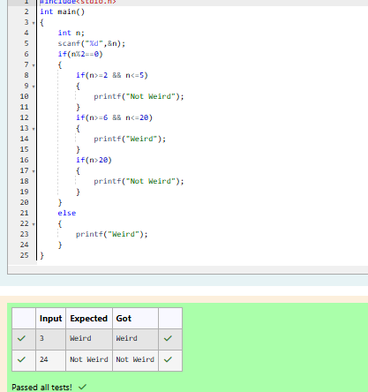

1. Three numbers form a Pythagorean triple if the sum of squares of two numbers is equal to the square of the third. For example, 3, 5 and 4 form a Pythagorean triple, since 3*3 + 4*4 = 25 = 5*5 You are given three integers, a, b, and c. They need not be given in increasing order. If they form a Pythagorean triple, then print "yes", otherwise, print "no". Please note that the output message is in small letters.

